**WEEK OF JANUARY 12 2025**

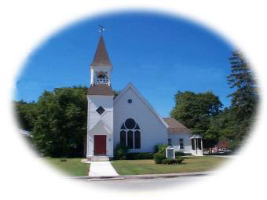

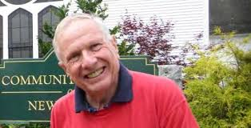**From Woody:** Some random thoughts on a January Monday.  First, I look forward to our annual Martin Luther King Celebration on Sunday.  He is a great hero of mine as he took the message of Jesus to the streets and changed our country for the better.  It is a sad fact that he was taken from us too soon.  Hope you will come and bring family and friends.  We are truly honored to have our new Congresswoman as our guest speaker.

On a related topic the USA TODAY has a story on the front page today talking about the increasing radicalization of members of military as exemplified by the New Year events in New Orleans and Las Vegas each carried out by military people.  There would seem to be growing danger for our soldiers, both of Post Traumatic Stress Syndrome and of accepting the culture of violence.  Of course, one can't really oppose violence and be subjected to the training to prepare for modern war.  We need need to find peaceful ways to solve international and national disputes.  War is not healthy for living things.

A lady visiting our church this past Sunday spoke to me about her concern for our New Hampshire Public Schools.  There now is money being sent to private schools by our state government which takes badly needed funds away from the foundation of a democracy, our public school system.  We need to pay attention to this because the cornerstone of a democracy is an intelligent, informed citizenry.  Private schools are fine but money for them should not come from our government.  Hope to see you this Sunday morning for a joyous and inspiring celebration.



**2025 Pledges:** Pledges for 2025 are still urgently needed as we begin to form a budget for the Annual Meeting on Jan. 26 after worship.  Please help by sending in your pledge if you have not already done so. And thank you to all those who have already pledged.

**Martin Luther King Celebration:**  Our special Martin Luther King Day service is scheduled for Jan. 19. Our speaker will be Maggie Goodlander, our new Congresswoman. This is always a special service and we hope to have a good crowd.

**Annual Meeting:** Our Annual Meeting will be after worship on January 26.  Please bring a dish to share as we traditionally have a Covered Dish luncheon followed by our meeting.

**QR Code:** You can use the QR code below to pay your pledge or other contribution.

QR Code: Or click on this link: <https://www.zeffy.com/en-US/donation-form/e47ab025-f0b0-40b4-90e6-f262bb1a29e1>



**Peace Quote:** Be the peace you wish to see in the world.......*Dr. Martin Luther King*